1)

Feature: Where do you want to go ?

Scenario: Customer travel alone from Amsterdam to Barcelona

Given The departure station is Amsterdam

And the arrival station Barcelona

And the departure day is today

And the return day is today +7

And the number of adult people is 1

And the number of children is 0

And the number of Babies is 0

When the customer press search

Then a new page open

And shows the options for the outbound flight only times in the future

And shows the options for the inbound flight

And gives you the option to change the input data

2)

Feature: Where do you want to go ?

Scenario: Customer travel alone from Amsterdam to Barcelona and the department day is in the past

Given The departure station is Amsterdam

And the arrival station Barcelona

And the departure day is today -1

And the return day is today +7

And the number of adult people is 1

And the number of children is 0

And the number of Babies is 0

When the customer press search

Then a new page open

And shows a new where do you want go screen

And the outbound day here is today +1

And the other preferences are the same as he filled in on the homepage

3)

Feature: Where do you want to go ?

Scenario: Customer want to book a trip for 26 people

Given The departure station is Amsterdam

And the arrival station Barcelona

And the departure day is today +1

And the return day is today +7

And the number of adult <adult> travelers

And the number of adult <children> travelers

And the number of babies <babies> travelers

When the customer press search

Then a new page open

And the Who will be traveling is red

And the customer get the red warning that he must filled in a group form

And the other preferences are the same as filled in on the homepage

|  |  |  |
| --- | --- | --- |
| Adult | Childeren | Babies |
| 26 | 0 | 0 |
| 13 | 13 | 0 |
| 12 | 14 | 0 |
|  |  |  |

4)

Feature Subscribe for Newsletter subscription

Scenario Customer wants to sign up for the newsletter

Given use roland@jahn.com

And the emailadress don’t receive a newsletter

When the customer click on subscribe

Then the customer receive a confirmation mail

And under the emailadress box displays the melding that the confirmation mail is send

The second assignment:

When the customer click in the upper right on the “ EUR” , he can change the valuta. If he changed it in to the dollar.

Check of the prices than be displayed in dollars.

This scenario can only be done if the country is “ Nederland” (Also not by “ Nederlands” the site is than English), if it has another language, the euro link is nog visible.

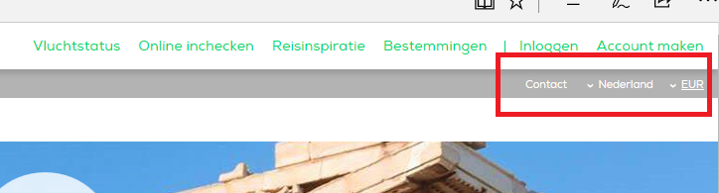

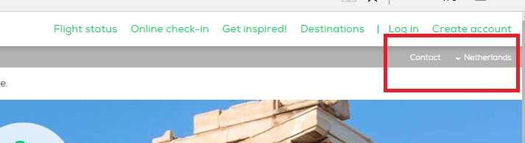

I don’t know of this is right, but it looks strange for me .

2)

In the footnote of the screen, click on about us and look of the link works an bring you to the page with the story about Transavia.